***Pascal Imitation Jewellery***

|  |  |  |
| --- | --- | --- |
| **Batch.** | 2407G2 | |
| **Group.** | C | |
| **Serial No.** | **Enrollment Number** | **Student Name** |
| 1. | Student1597584 | ARZAM NAVAID |
| 2. | Student1597219 | M.ABDULLAH |
| 3. | Student1597526 | M.HASSAAN RAZA |
| 4. | Student1596608 | TAHA FAISAL MANSOOR |
| 5. | Student1597219 | M.ZAIN KHAN |

|  |  |
| --- | --- |
|  |  |
|  |  |
|  |  |
|  |  |
|  |  |
|  |  |

***User Guide***

***1.Welcome (0.Welcome.html)***



***Figure 1: Welcome Page To pascal Jewellery.***

***2.Layout Top***



* Home Page (1.Index.html)
* Products Page (2.Products.html)
* About Us Page (3. About Us.html)
* Contact Us Page (4. Contact Us.html)
* Gallery Page (5. Gallery.html)

***3.Layout Bottom.***

***Footer***



***Figure 5 : Layout Bottom.***

4.Product page (1.preciousproduct.html)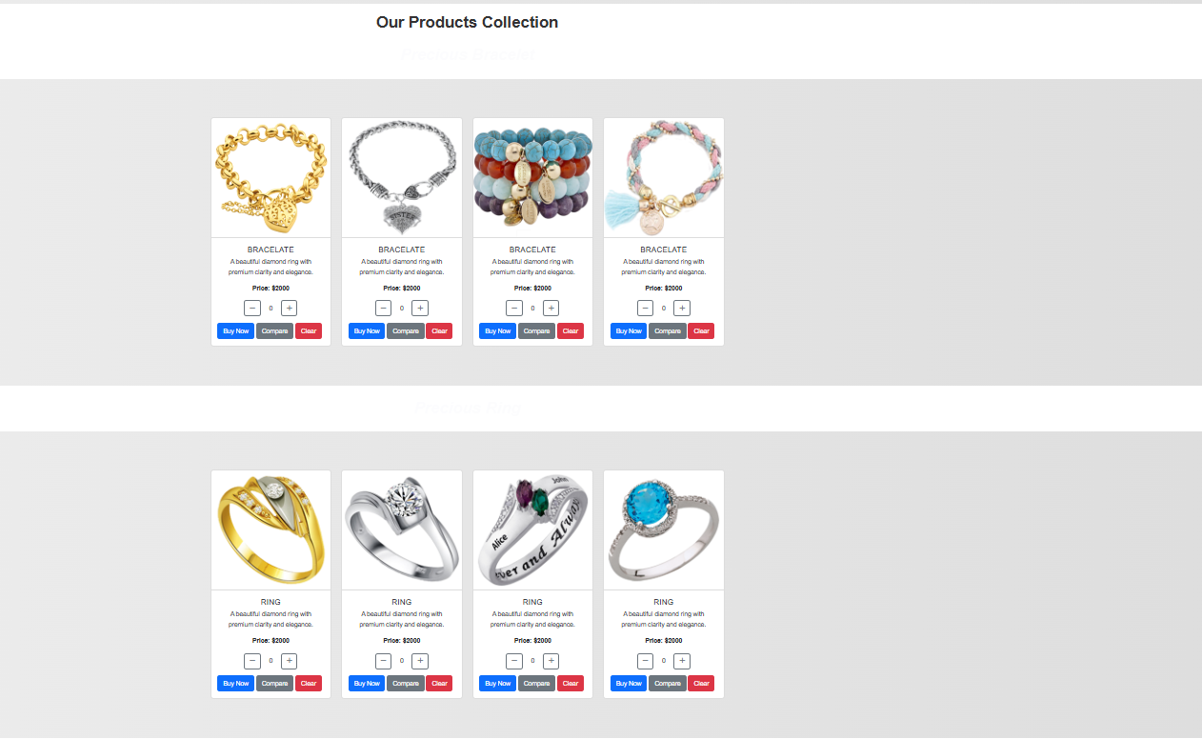

***Figure 6 : Home Page.***

***The interface of the Home page is shown as Figure.***

5.Products Page (2.Products.html)

***Figure 7 : Products Page.***

* ***The interface of the Products page is shown as Figure: Products Page.*** ***When the user clicks on the product, the product details page will appear.***

***Figure 8 : Products Line-Up.***

***But the page details product lines:***

**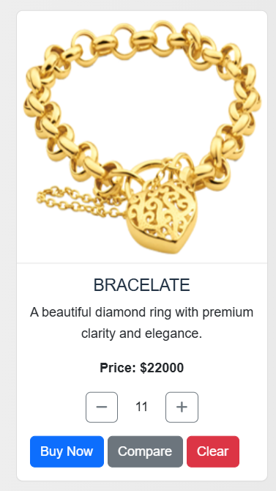 *Figure 9 : Buy Now.***

* ***When the user clicks the View This Product In-Store button, a container will be dropped.The container is shown in Figure: View This Product In-Store.***

